5 Amazing Tips for Data Visualization
Quickly turn data into something insightful.

Shutterstock by majcot
Is there a such thing as data visualization block for analysts? Like a painter who stares at a blank canvas or a writer who can’t write that first sentence — you might be an analyst just staring at a wall of data in Excel.
Or maybe you just feel like an old dog that wants to learn a new trick?
This list contains my 5 favorite techniques for consistently pumping out effective data visualizations. It also helps prevent this dreaded data visualization block. Goodbye wall of data… hello insight!
- Scatter plot your two most interesting metrics
While reviewing a new dashboard for a stakeholder, we got a comment that really got me thinking. They said, “This is great in describing exactly what happened, but there is not much insight for taking action.”
In Business Intelligence, it is often much easier to visualize what happened rather than visualizing actionable insights.
This is where the scatter plot comes in.
Scatter plots are famously used to assess correlation between two metrics. Often overlooked, they actually have another use case. This variation is often referred to as a quadrant plot.
First, identify two important or interesting metrics. Second, have at least one dimension that you can take action with such as state, employees, or marketing campaigns. Then scatter away!
For example, in marketing, we often care about two metrics. Marketing performance in efficiency (acquiring as many customers as possible at a low marketing spend). Marketing performance in quality (acquiring customers that are high value).
When we scatter these two metrics by campaign we can quickly and clearly see the good and the bad.
Press enter or click to view image in full size
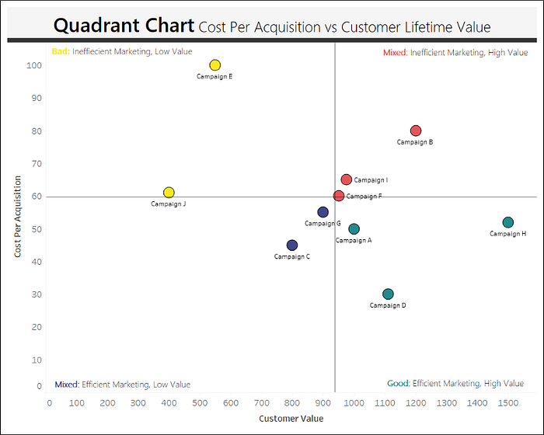
Made with Tableau
The action from this scatter plot is to take money away from campaign E and J and put it towards D and H. This works so well because it sorts your dimension into four easy to understand quadrants.
Ben Jones, a data visualization expert, initially showed me this variation of the scatter plot. So, for a second example here is one of his quadrant charts. He is using color as a third dimension rather than assigning color to quadrant.
Press enter or click to view image in full size
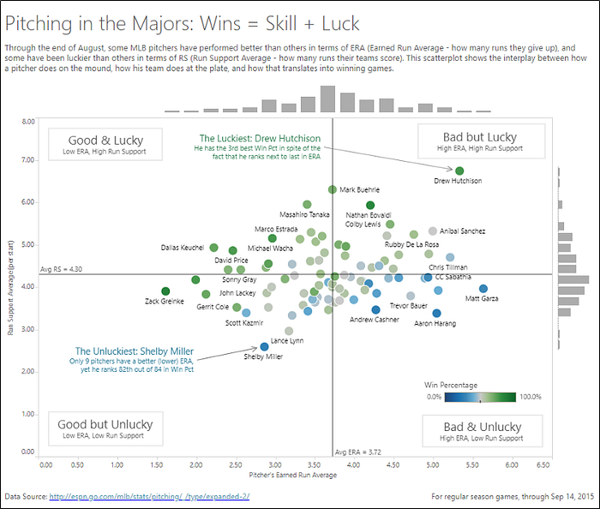
Visualization on Tableau Public
I have found myself in many awkward, unlucky situations being a guy named Shelby. This visualization makes me feel better because Shelby Miller is not just a guy named Shelby, but also the unluckiest pitcher as well.
There is some belief that scatter plots are too complex for the non-technical audiences. That non-technical audiences can only understand bar charts and line graphs. I refuse to believe this. I really think this line of thinking is dated. We live in the internet and big data era and are much more aware of data analytics. Pretty sure most people have seen scatter plots.
On the job, I have never shown the quadrant chart to a non-technical person and it was a flop. Quite the opposite if I must be honest.
2. Promote comparisons using many of the same data visualization
Design theorist, Edward Tufte, said “The only thing worse than a pie chart is several of them.”
Although I find the quote funny, I actually disagree with Edward Tufte. He has a second, more important quote that contradicts this first quote.
“For a wide range of problems in data presentation, small multiples are the best design solution.”
Small multiples is using the same data visualization over and over to promote comparisons. Let’s jump right into an example where pie-mania works. This was created by data visualization expert Ann Jackson.
Press enter or click to view image in full size
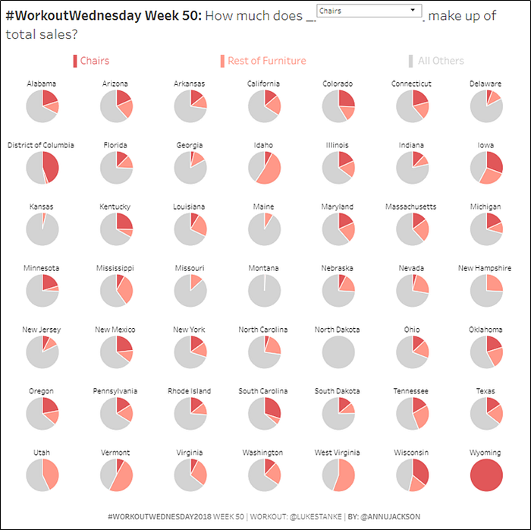
Visualization on Tableau Public
Descriptive analytics is at its best when you can make comparisons across objects. What if we rolled all these pies up into just one and said, “In the US chairs make up 25% of sales.” Without context it is hard to quickly understand what that means.
Small multiples can give the audience context lightning quick. Our eyes and brain are wired to quickly detect when one thing is not like the other. Probably helped with surviving or something like that.
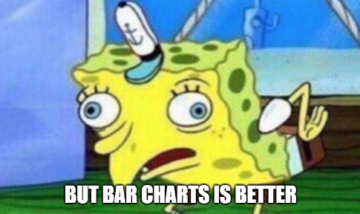
Bar charts would actually take away that this metric is adding up to 100%. Sorry pie haters, this is actually a situation where the pie chart is the better choice. Let’s not get carried away though — when in doubt bar chart it out.
Just wanted to note that small multiples are also sometimes called a trellis chart.
3. Securing clarity allows you to create clarity
If you are sitting at your computer not knowing where to begin you might be missing something very important — project clarity.
Start by asking yourself two questions.
- Has my client/stakeholder clearly stated the question they want answered?
- Have we agreed on the metrics and calculations I am going to use in my data set?
Sounds simple right? Yet I have seen and been involved in so many projects that lose sight of the goal, the business, the purpose, the question, etc.
Our most successful dashboards generally have two qualities, good data and a laser focus on the questions we want to answer.
This tip is a simple two step process:
- Secure clarity from client/stakeholder
- If you cannot secure clarity from client/stakeholder put yourself in their shoes and create your own questions to ask the data
That’s why securing clarity allows you to create clarity! Goodbye wall of data… hello insight!
4. Control chart for time series variation
Our sales are down 20% from last week! Sound the alarms. Quick query a bunch of random things and call them “drivers”!
Yikes! This is one of the most common, unfortunate situations in descriptive analytics. What is the chance you will uncover the true combination of factors that caused sales to decrease 20% from prior week? Slim to none.
This tip will help you at least start to understand if this 20% decrease is actually noteworthy or maybe just random variation based on historical results.
Time series have distributions. You can histogram a metric with week as the frequency. You can use the distribution and variation to calculate a standard deviation. With that, you can wrap your time series chart with an upper and lower bound.
Press enter or click to view image in full size
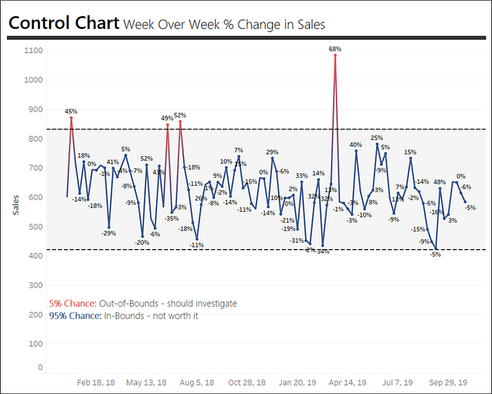
Made with Tableau
The control chart helps us assess if the increase and decrease seems to be truly unusual or more just random variation. Instead of dedicating an entire afternoon to a firedrill analysis we might be able to push back and say a 20% decrease is absolutely normal.
Based on my sales data above you can actually see May 13, 2018 there was a 20% decrease in sales over the prior week. However, it is within the control chart bounds so we can assess it as normal variation within the data — and instead focus on the weeks that are truly abnormal.
If you want to control chart in tableau here is a tutorial.
Need more help preventing these time series fire drills? Better options are to supplement the descriptive analytics with A/B testing or quasi measurement approaches such as difference in difference. I really like a package open sourced by Google called CausalImpact that helps separate random variation from true impacts via time series modeling.
5. Allocate a significant chunk of your time to design and formatting
Next time you present to an audience. Open with this line, “I wish to build zero credibility and zero trust with you today.” No one has ever opened with that.
The whole point of data visualization is to communicate to an audience. In data and analytics credibility and trust are crucial and fragile.
Design and formatting is one of the easiest ways to appear professional, credible, and build trust with an audience. Yet time and time again I see people spending little effort on design and formatting. It’s a shame when the analysis and data are terrific but it never resonates with the audience.
Data visualization is more than just crunching numbers and displaying the results. The goal is to be insightful and engaging.
I like how Ryan Sleeper puts it in his book Practical Tableau, “…without balancing quality of your data with a quality design, your data visualization will never reach its full potential.”
Time to carve out at least some of your schedule purely dedicated to design. I will send you to the chalkboard if you disagree.
